UNIT 3ACHE NAME:

ATOMIC STRUCTURE & BONDING: Answer all questions

Part A: Multiple Choice Questions. (10 marks)

Q1. The species 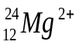 contains

A. 12 protons, 12 neutrons and 12 electrons
B. 12 protons, 12 neutrons and 14 electrons
C. 12 protons, 10 neutrons and 10 electrons
D. 12 protons, 12 neutrons and 10 electrons

Q2. Some information about the element rhenium (Re) is given in the table below.
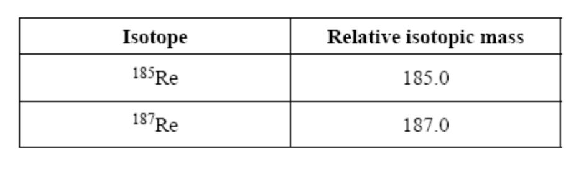
Given that the relative atomic mass of Re is 186.2, the percentage abundance of ¹⁸⁵Re is closest to

A. 40
B. 50
C. 60
D. 70

Q3. Which statement cannot be true of two atoms with the same mass number?

A. They have different numbers of protons
B. They are isotopes of the same element
C. They have different numbers of neutrons
D. They are atoms of two different elements

Q4. Which one of the following alternatives lists the atoms of chlorine, fluorine, magnesium and potassium in order of decreasing atomic radius?

A. (largest) K, F, Mg, Cl (smallest)
B. (largest) F, Mg, Cl, K (smallest)
C. (largest) K, Mg, Cl, F (smallest)
D. (largest) F, Cl, Mg, K (smallest)

Q5. Which of the following energy changes refers to the first ionisation energy of oxygen:

A. ½ O_{2(g)} O⁺_{(g)} + e⁻
B. ½ O_{2(g)} + e⁻ O⁻_{(g)}
C. O_{(g)} + e⁻ O-_{(g)}
D. O_{(g)} O⁺_{(g)} + e⁻
Q6. The following table gives the electronegativities of some elements :

Element | Electronegativity | Element | Electronegativity
bromine | 2.8 | nitrogen | 3.0
hydrogen | 2.1 | chlorine | 3.0
carbon | 2.5 | oxygen | 3.5

Which one of the following bonds would be expected to be most polar?

A. C - H B. N – O

C. N – C D. H - Br

Q7. Carbon and silicon are both members of Group 14 on the periodic table.
Carbon dioxide is a gas at room temperature while silicon dioxide is a solid because

A. Van der Waals forces are much weaker than covalent bonds.
B. carbon dioxide contains double covalent bonds while silicon dioxide contains single covalent bonds.
C. carbon-oxygen bonds are less polar than silicon-oxygen bonds.
D. the relative formula mass of carbon dioxide is less than that of silicon dioxide.

Q8. The diagram below shows two methanol molecules.

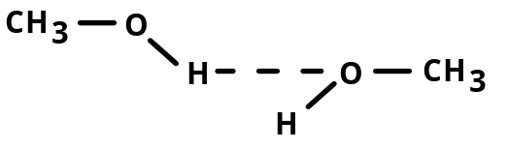

The dashed line (- - -) in this diagram represents

A. a non-polar covalent bond between the oxygen atom and the hydrogen atom .
B. a polar covalent bond between the oxygen atom and the hydrogen atom.
C. a hydrogen bond between the methanol molecules.
D. dispersion forces between the methanol molecules.

Q9. Consider the following four molecules: (Cl₂, BCl₃, SiCl₄, and NH₃).
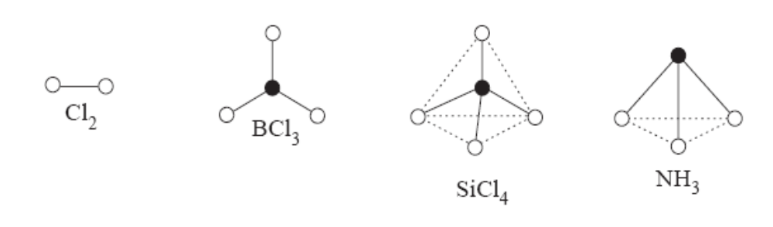
Which ONE of the following statements is TRUE?

A. None of the molecules has an overall permanent dipole.
B. Only one of the molecules has an overall permanent dipole.
C. None of the molecules contains dipoles.
D. Two of the molecules have the same shape.

Q10. Two of the compounds shown below react together to form a new compound with a
coordinate covalent bond.

Which of the following compounds react this way?
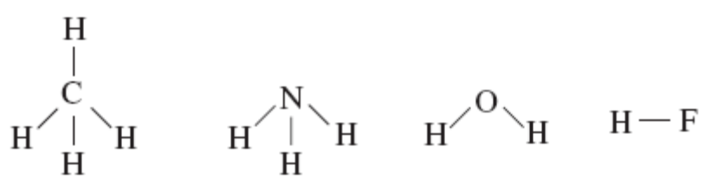

A. Methane and ammonia
B. Methane and water
C. Hydrogen fluoride and ammonia
D. Hydrogen fluoride and methane

END OF PART A

PART B: SHORT ANSWER QUESTIONS (15 marks)

11. The successive ionisation energies, in kJ mol⁻¹, of an unknown element are listed in
the table below.

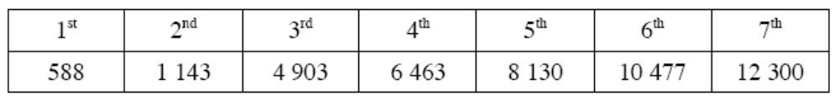

From this data predict the following:

A. The charge on the ion that the element, normally, forms and give a reason for your choice.

Reason

(2 marks)

B. Given that the element is in Period 4, write the balanced equations for its
reactions with oxygen, hydrogen and water?

With oxygen

With hydrogen

With water
(3 marks)

12. A gaseous element, X, has the properties of a non-metal, and forms compounds with chlorine, sodium and hydrogen. The empirical formulae of these compounds are all inthe ratio 1:3.

Identify the element, clearly indicating your reasons.

Reasons

(2 marks)

13. Describe and explain the trend in atomic radii of the atoms Na, Mg, Al and Si.

(2 marks)
Describe the trend in the atomic radii of the atoms F, Cl, and Br. Explain how this
affects their ease of conversion to the ion, F⁻, Cl⁻, and Br⁻.

(3 marks)

14. Consider the main groups in the Periodic Table.

A. Explain why elements within a group react similarly.

(1 mark)
B. Give a reason why caesium is more reactive than the lower atomic mass alkali
metals.

(1 mark)
C. Give a reason why fluorine is the most reactive halogen.

(1 mark)

PART C: EXTENDED ANSWER SECTION (15 marks)

Q15. A. The graph shows the first five ionisation energies for sodium, aluminium
and magnesium.

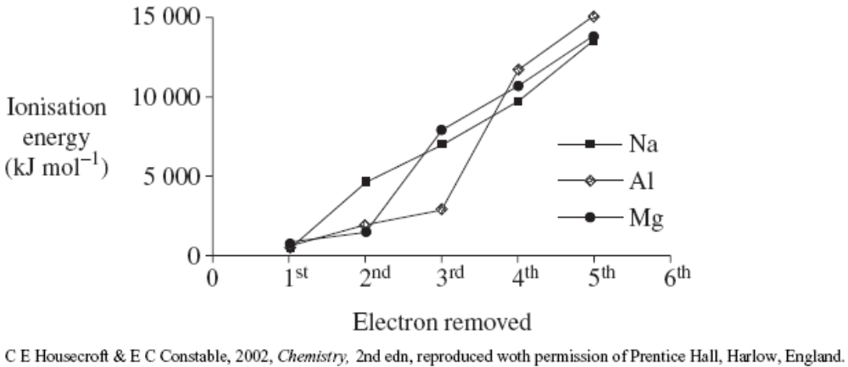

Explain how the data can be used to provide information about the arrangement of electrons around the atoms.

(2 marks)

Q16. Draw an electron dot diagram or Lewis diagram for each of the following species, representing ALL valence electron pairs as : .

Species | Structural formula (showing all valence shell electrons) | Shape (draw or state name)
CO₂

CH₂O

HCO₃⁻

(3 marks)

Q17. Tools in a sea water aquarium had acquired an estimated 50 g of rust, Fe₂O₃. The rust was removed by treatment with oxalic acid, H₂C₂O₄, according to the following equation.
Fe₂O_{3(s)} + 6H₂C₂O_{4(aq)} → 2Fe(C₂O₄)₃³⁻_{(aq)} + 6H⁺_{(aq)}

Calculate the minimum volume of a 2.00 molL⁻¹ solution of oxalic acid that would be required to remove 50.0 g of rust. (3 marks)

Q18. A gold purification process uses the following reactions.
Impure gold is reacted with potassium cyanide, KCN, forming the compound
KAu(CN)₂. This is then treated with zinc. The reaction is:

2KAu(CN)₂ + Zn → K₂Zn(CN)₄ + 2Au

3.90 kg of KAu(CN)₂ was reacted with 1.10 kg of Zn.

A. Calculate the maximum mass of pure gold which could be obtained from this
reaction. (4 marks)

B. What mass of the reagent in excess is left over after the reaction is complete?
(3 marks)

END OF TEST

UNIT3BCHE SOLUTIONS

STRUCTURE AND BONDING: Answer all questions

PART A: MULTIPLE CHOICE QUESTIONS (10 marks)

1D | 2A | 3B | 4C | 5D | 6D | 7A | 8C | 9B | 10C

PART B: SHORT ANSWER QUESTIONS (15 marks)
Q11.
A. 2+
The energy required to remove the 3rd electron is very much higher than that required to remove the 2nd electron, this indicates that the 3rd electron is from an inner “shell”, therefore there are 2 valence electrons.

B. 2Ca + O₂ → 2CaO
Ca + H₂ → CaH₂
Ca + 2H₂O → Ca(OH)₂ + H₂

Q12. Nitrogen
NCl₃, Na₃N and NH₃ fits an empirical formula of 1:3.
N has a valency of 3
N₂ is gaseous and a non-metal whereas P is a solid, therefore element X cannot be phosphorus.

Q13. Atomic radius decreases from Na → Si
Outer electrons in the same “shell” but as we go from left to right there is an increasing nuclear charge (extra proton added each time) and this causes a decrease in atomic radius from left to right

Atomic radius increases from F → Br
The halogens gain electrons to form X⁻ ions
The smaller the radius, the closer the nucleus is to the surface of the atom, hence the more reactive (i.e. the easier it is for them to form X⁻ ions) they are and the easier it is for them to capture an electron. As a consequence reactivity decreases form F → Br.

Q14.
A. They have similar electron configurations (arrangements) i.e. the same number of valence electrons (electrons in the outermost energy level). Consequently they have similar processes (reactivity) in attaining stable electron configurations.
B. It is a large atom, therefore has a lower ionisation energy than the lower atomic mass alkali metals, therefore it is more reactive.
C. It is the smallest halogen and since its nucleus is so close to its surface, it is extremely good at capturing electrons (i.e. it is a strong oxidant/oxidising agent/oxidiser)

Q15. A very large “jump” (large increase) in removing a successive electron indicates that that electron comes from an inner “shell”

For Na the large increase is on the 2nd electron, hence there is 1 valence electron.
For Mg the large increase is on the 3rd electron, hence there are 2 valence electrons.

For Al the large increase is on the 4th electron, hence there are 3 valence electrons.
Q16.
Species | Structural formula (showing all valence shell electrons) | Shape (draw or state name)
CO₂ | .. ..  : O : : C : : O : | Linear
CH₂O | H  .. ..  H : C : : O : | Triangular Planar
HCO₃⁻ | ―  .. ..  : O : : C : O : H  .. ..  : O :  .. | Combinations  (triangular planar around the carbon and HOC bond angle is V-shaped)

Q17.
n(Fe₂O₃) = 50 ÷ 159.7 = 0.31308 mol
n(H₂C₂O₄) = 6 x n(Fe₂O₃) = 6 x 0.31308 = 1.8785 mol
n = CV; V = n/C
V = 1.8785 ÷ 2 = 0.939 L or 939 mLs

Q18.
A. n(KAu(CN)₂) = 3.9 x 10³ ÷ 288.14 = 13.53 mol
n(Au) = n(KAu(CN)₂) = 13.53 mol

n(Zn) = 1.1 x 10³ ÷ 65.38 = 16.82 mol
n(Au) = 2 x n(Zn) = 2 x 16.82 = 33.64 mol

KAu(CN)₂ is limiting as it produces the least amount of Au

m(Au) = n(Au) x M(Au) = 13.53 x 197 g = 2670 g or 2.67 Kg or 2.67 x 10³ g

B. n(Zn)_{reacting} = ½ x KAu(CN)₂ = ½ x 13.53 = 6.767 mol
m(Zn)_{reacting} = 7.767 x 65.38 g = 442.4 g
m(Zn)_{inxs} = m(Zn)_{init} ― m(Zn)_{reacting} = 1100 ― 442.4 = 658 g

